Problem Set G Submission Form

# Overview

|  |  |
| --- | --- |
| Your Name | Jaya Varshini Prabakar |
| Your SU Email | jprabakar@syr.edu |

# Instructions

Put your name and SU email at the top. Answer these questions all from the lab. When asked to include screenshots, please follow the screen shot guidelines from the first homework.

Remember as you complete the homework it is not only about getting it right / correct. We will discuss the answers in class so it’s important to articulate anything you would like to contribute to the discussion in your answer:

* If you feel the question is vague, include any assumptions you've made.
* If you feel the answer requires interpretation or justification provide it.
* If you do not know the answer to the question, articulate what you tried and how you are stuck.
* Highlight any doubts or questions you would like me to review.

This how you receive credit for answering questions which might not be correct. In addition, you must complete the reflection portion of the homework assignment for full credit. Since most answers will be similar this is an important part of your individual submission.

Complete Part II of this document first, then go back and complete the Reflection in Part I.

# Part I - Reflection

Use this section to reflect on your learning. To achieve the highest grade on the assignment you must be as descriptive and personal as possible with your reflection.

1. As you completed this assignment, identify what you learned.  
   This Problem set helped me learn how to create tables in canssandra, query in Cassandra and also create index in it
2. What barriers or challenges did you encounter while completing this assignment?

It was hard to figure out qn 10, but the video walkthrough helped.

1. How prepared were you to complete this assignment? What can you do to be better prepared?  
   I was prepared.
2. Rate your comfort level with this week’s material. Use the rubric provided.

4  
4 ==> I understand this material and can explain it to others.  
3 ==> I understand this material.  
2 ==> I somewhat understand the material but sometimes need guidance from others.  
1 ==> I understand very little of this material and need extra help.

# Part II – Questions

Your employer (weather.com) would like you store weather sensor and forecast data. Eventually you will get readings from 2,000 cities worldwide every minute. That's 2.88 million rows each day and 1 billion rows a year! Since the data does not need to be read immediately when written across all nodes, you decide Cassandra is a good choice for this project! This data will be accessible by users so they can get weather information and historical trends for they cities they live in and visit. This should help you figure out how the data will be queried.

**QUESTIONS:   
  
For each question, include a copy of the code required to complete the question along with a screenshot of the code and a screenshot of the output.**

1. InCQL, create a Keyspace called **glab** with a replication factor of 1 and a Simple replication strategy. Use the keyspace.   
   **code:**

create keyspace glab with replication = {'class':'SimpleStrategy','replication_factor': 1};

**Screenshot:**

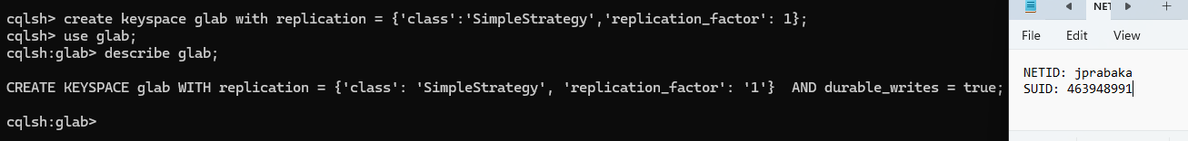

1. In Spark, setup a spark session that is ready to talk with Cassandra.  
   **Code:**

import pyspark

from pyspark.sql import SparkSession

from pyspark.sql.functions import *

from pyspark.sql.types import *

# CASSANDRA CONFIGURATION

cassandra_host = "cassandra"

spark = SparkSession \

.builder \

.master("local") \

.appName('jupyter-pyspark') \

.config("spark.cassandra.connection.host", cassandra_host) \

.config("spark.jars.packages","com.datastax.spark:spark-cassandra-connector-assembly_2.12:3.1.0")\

.getOrCreate()

sc = spark.sparkContext

sc.setLogLevel("ERROR")

**Screenshot:**

1. To deal with the amount of data associated with the weather.com dataset, you decide to start with a smaller sample data set. The dataset contains 7 days of weather information for major US Cities, with one row being weather information for a single city on a single day. Load the dataset Located at **/home/jovyan/datasets/weather/weather.json** and use printSchema() to inspect the schema.  
   **Code:**

w_df = spark.read.json("file:////home/jovyan/datasets/weather/weather.json")

w_df.printSchema()

**Screenshot:**

1. Look at rows of data in the sample data set. Profile the data to determine what should be used as the partition and cluster key:
   1. First: Find the minimal candidate key - which columns serve as a key for each row?   
      NOTE: You can NOT use 2020census as that is a population figure and coincidentally unique.

Ans: To uniquely identify a row the columns such as City, State and Date can be a minimal Candidate key for this weather dataset.

* 1. Next: Prove your key works, in Spark:
     1. Get a count of rows in the entire DataFrame.

**Code: print(w_df.count())**

* + 1. Get a count rows when you select your key columns and use distinct() to remove duplicates.

**Code:** **print(w_df.select("date","city","state").distinct().count())**

* + 1. If the row counts are the same, that’s a candidate key. include the code and output in the screenshot.

Totally Distinct rows count:

Distinct Count of candidate key rows

* 1. A Cassandra row key consists of a partition and cluster key.   
     For this example, use the column that will guarantee to be storing data in increasing order over time (append only) as your cluster key. The other column (or columns) should be the partition key  
     Based on the column that will guarantee storing data in increasing order, the

**Cluster key is date and the partition keys are State and City.**

1. With your keys figured out, its time to create your table. Using the CQL Shell, write an CQL Query to create a table called **daily_city_weather**. Include all columns in the source data set, and make sure to set your partition and cluster keys, as designed. Show the CQL query and the output in the screenshot. Include an additional screenshot of the describe command on this table.  
   ADVICE: Write your create table in a text editor then paste it into CQL, as the command line can be a tad unforgiving.  
     
   **Code:**

create table if not exists glab.daily_city_weather(

census2020 int,

city text,

condition text,

weatherdate date,

description text,

dew_point decimal,

latitude decimal,

longitude decimal,

moon_phase decimal,

pct_clouds int,

pct_humidity int,

pressure int,

rainfall decimal,

snowfall decimal,

state text,

temperature_day decimal,

temperature_eve decimal,

temperature_max decimal,

temperature_min decimal,

temperature_morn decimal,

temperature_night decimal,

timezone text,

uv_index decimal,

wind_direction_deg int,

wind_gust decimal,

wind_speed decimal,

primary key((state,city),weatherdate));

describe tables;

**Screenshots:**

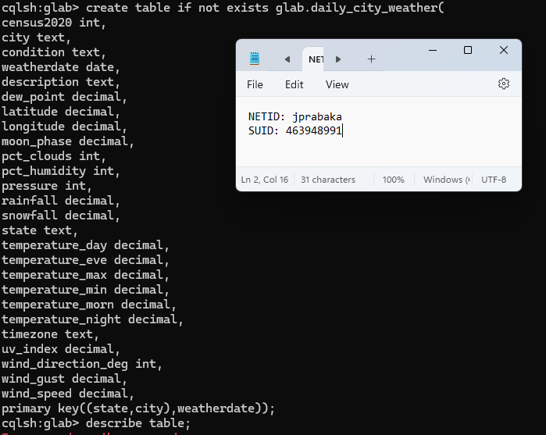

1. Write spark code to save the json dataframe into your Cassandra table. Make sure the column names are the same. Read the data back out and make sure you have the same number of rows in the dataframe and in the Cassandra table. This will be further proof that your Cassandra row key is setup correctly. Provide spark code to save the data to Cassandra and then a screenshot of a select statement and output in the CQL Shell.

**Code:**

weather = w_df.toDF("census2020",

"city",

"condition",

"weatherdate",

"description",

"dew_point" ,

"latitude",

"longitude",

"moon_phase",

"pct_clouds",

"pct_humidity",

"pressure",

"rainfall",

"snowfall",

"state",

"temperature_day",

"temperature_eve",

"temperature_max",

"temperature_min",

"temperature_morn",

"temperature_night",

"timezone",

"uv_index",

"wind_direction_deg",

"wind_gust",

"wind_speed")

weather.write.format("org.apache.spark.sql.cassandra")\

.mode("Append")\

.option("table","daily_city_weather")\

.option("keyspace","glab")\

.save()

CQL query : select * from daily_city_weather where city = 'Sunnyvale' and state = 'California';

**Code to check the count :**

weather2 = spark.read.format("org.apache.spark.sql.cassandra")\

.option("table","daily_city_weather")\

.option("keyspace","glab")\

.load()

weather2.count()

**Screenshots:**

1. Write a CQL Shell query to get the condition, description and daytime temperatures for "Syracuse, NY" include all dates.

**CQL query**:

select city,state, weatherdate,condition,description, temperature_day from daily_city_weather where city = '

Syracuse' and state = 'New York'

**Screenshot:**

1. Write the same query as 7. But using Spark SQL. Register the data From Cassandra as the Temp View **daily_city_weather**, then use Spark SQL To filter on “Syracuse, NY”. Instead of showing the output, **explain()** the spark query to prove the filter is being passed-through to Cassandra (The filter should NOT be happening in spark – Welcome to big data country!)

**Code:**

weather2.createOrReplaceTempView("daily_city_weather")

query = '''

select city, state,weatherdate,condition,description, temperature_day from daily_city_weather where city = '

Syracuse' and state = 'New York'

'''

spark.sql(query).explain()

**Screenshot:**

1. Your company would like to now allow users to find cities where it is raining on a specific date. Specifically, they would like a query to show the city and state name, date, condition, and description for only those cities where its not raining on the given date. Write this query in Spark or Spark SQL. Which Cassandra filters are used? Show with explain and highlight in your screenshot.

**Code:**

query = '''

select city, state,weatherdate,condition,description, temperature_day from daily_city_weather

where condition = 'Rain' and weatherdate = '2021-10-23'

'''

spark.sql(query).show()

**Screenshot:**

**Screenshot for explain:**

The filters used here is only cluster key which is weatherdate, while the other condition = ‘Rain’ performs indexing.

1. Run the same query in 9 from the CQL command line, obviously it requires ALLOW FILTERING. Figure out how you can do an index or materialized view to avoid a costly ALLOW FILTERING operation. Include your CQL to create the index or materialized view and then include a query demonstrating it works in CQL.   
   NOTE: Our version of Cassandra and the Spark Connector does not support Materialized Views.

For this I create a view that has partition key weatherdate and created an index view on that table.

**Code:**

create index ix_weatherDT on weather_date (condition);

select city, state,weatherdate,condition,description, temperature_day from weather_date

where condition = 'Rain' and weatherdate = '2021-10-23';

**Screenshot:**

